**Creating Simple Custom React Hook Example**

1. Node JS and React JS CLI must be installed.
2. Open the terminal or command prompt inside project ie **simple-custom-hook**
3. Then run npm install to download the required dependencies.

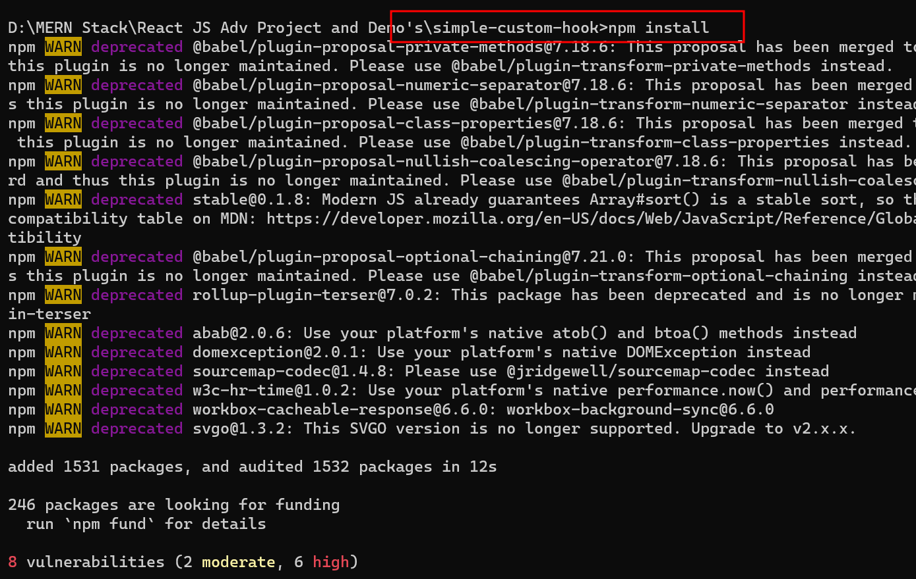

1. Then open the project in VC Code.

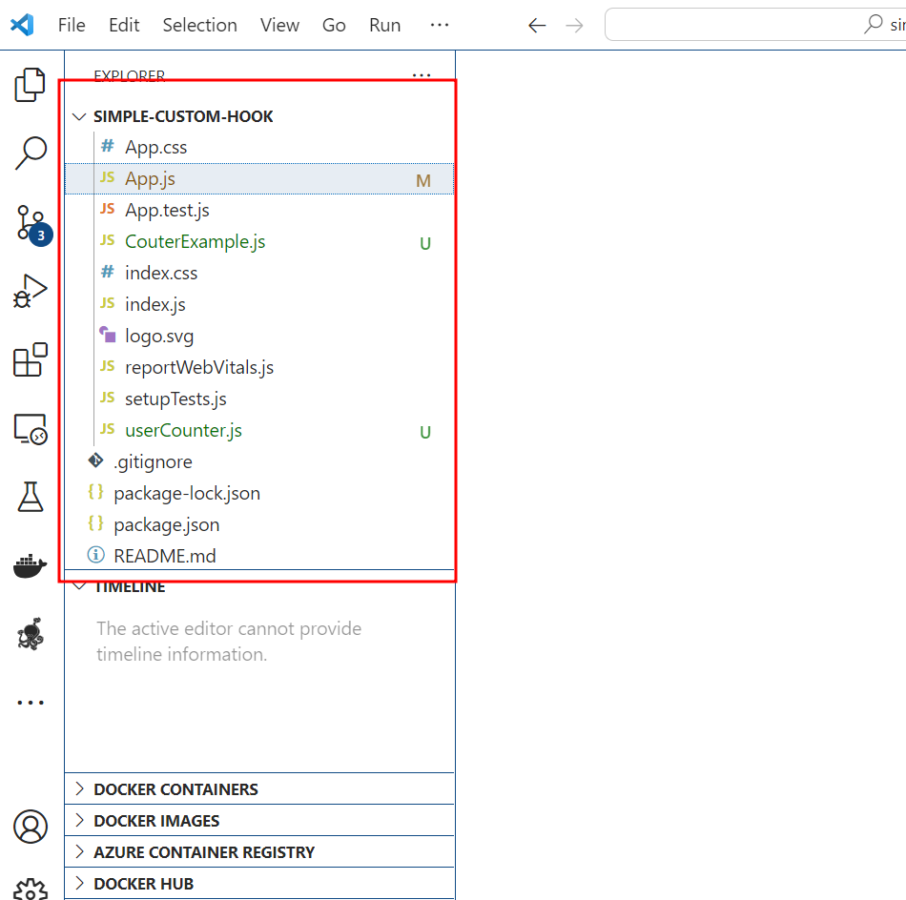

1. Now create **userCouter.js** file which contains the logic to create Custom hook.

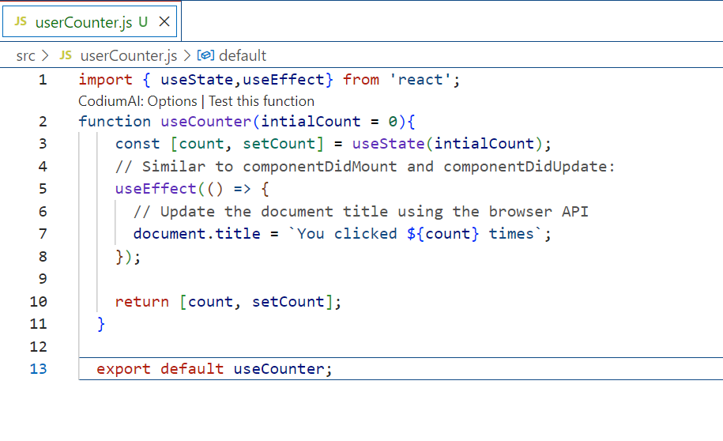

1. Now we need to use this useCounter custom hook in our any component depending upon our requirements.

So now we will create the **CouterExample.js** file

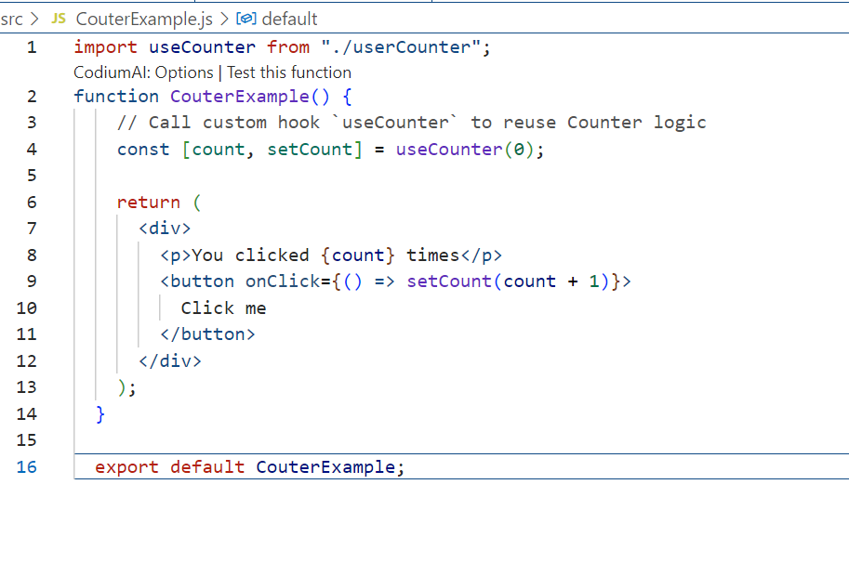

1. Now we need to import the CouterExample component in App.js file

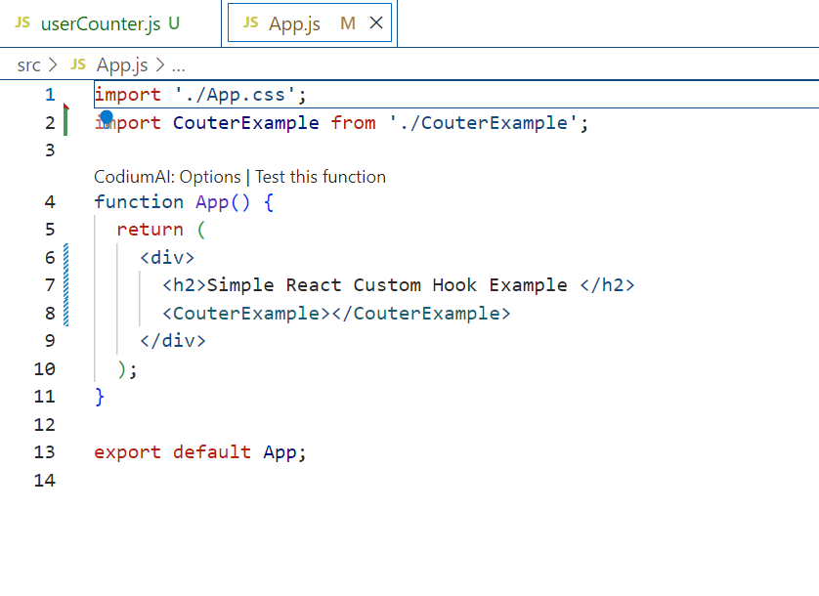

1. Now we need to run the application using the command as **npm start** and view the application in browser.

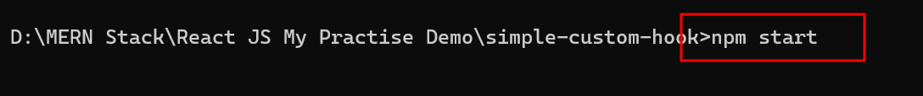

Now you can see the application in browser.

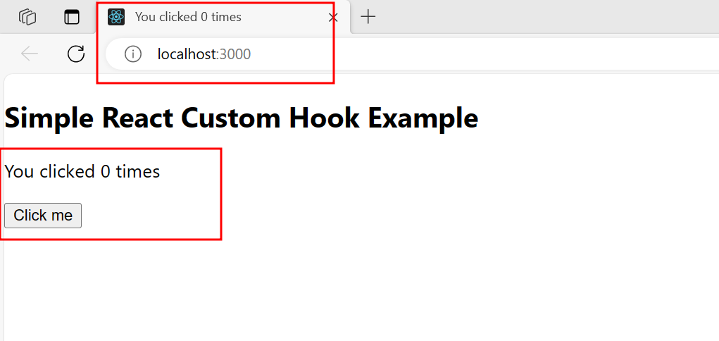

1. After click on button to get the incremented values in browser as well as title bar.

